**<<PET FOOD SHOP>>**

**Software Requirement Specification**

**Table of Contents**

I. Overview 2

1. Introduction 2

2. System Functions 3

II. Functional Requirements 4

1. Login 4

2. Registration 4

3. Admin page 5

4. Shopping page 5

5. Show list of food 6

6. Search by Name 6

7. Confirm Order 7

**I . Overview:**

1. **Introduction:**

* My project is about pet food store website. Web includes features for admin and user. Here, admin can manage user accounts and products for sale. Users can register for an account and order the products they want to buy.
* Customer information storage:

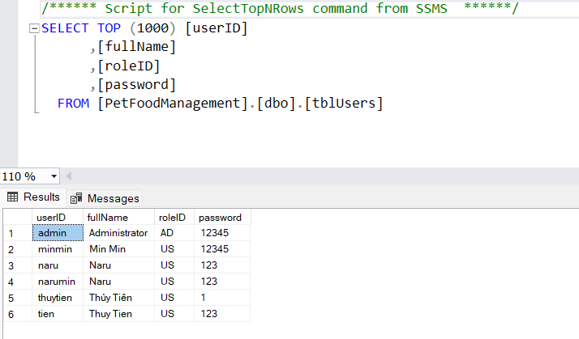

* Product information storage:

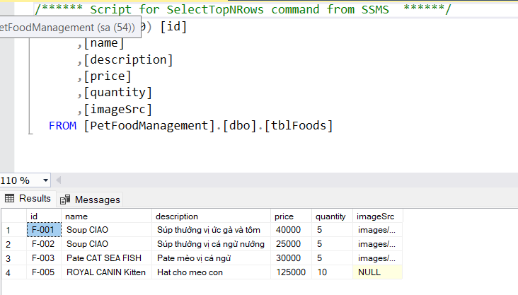

1. **System Function:**
2. Screen flow:

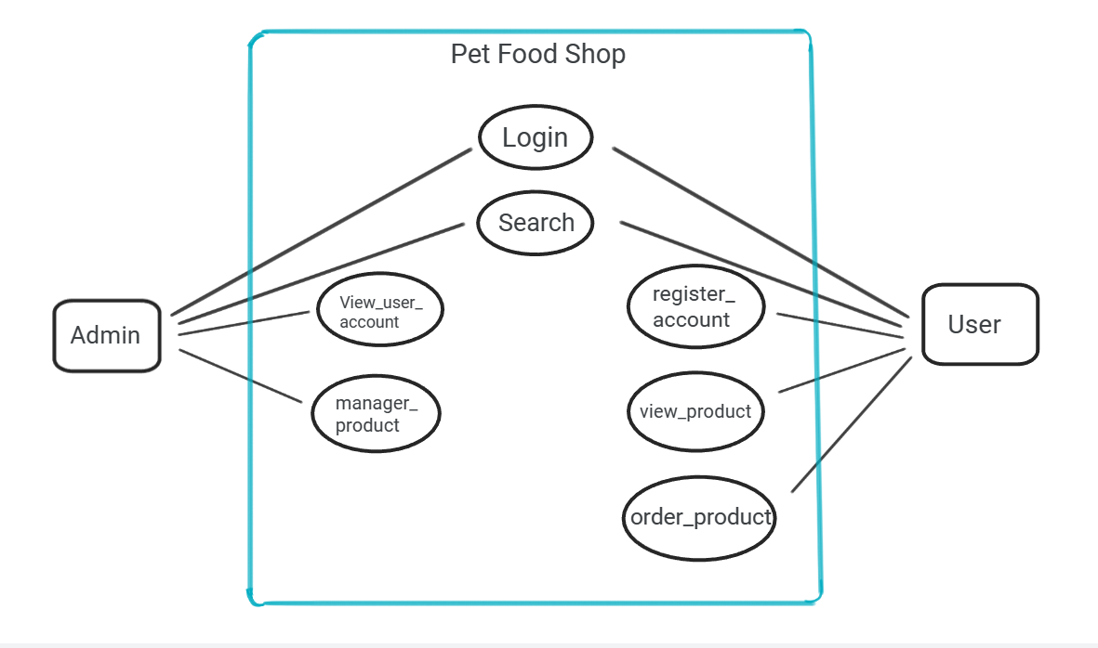

1. Screen details:

* ***User Web Application:***

|  |  |  |  |
| --- | --- | --- | --- |
| **#** | **Feature** | **Screen** | **Description** |
| 1 | Shopping | Shopping Page | Contains the main features of the application. |
| 2 | Get list of food | Shopping Page | List of food. |
| 4 | Get food detail | View Cart | Contains food details about food information, quantities textbox, add to cart button |
| 5 | Login account | Login page | Contains text box to input username and password, login button, register link. |
| 6 | Register account | Register page | Contains text box to input user information, register button |
| 7 | Log out | Login page | Click button log out |
| 9 | Buy food | Confirm food | Contains user’s information, quantities , price, add more button. |

**II . Funtrional Requirements:**

1. Login:

* Function trigger: after clicking login button or click the button to logging in.
* Function description: The system allows users to use their username and password to log in to the system as customer .
* Screen layout:

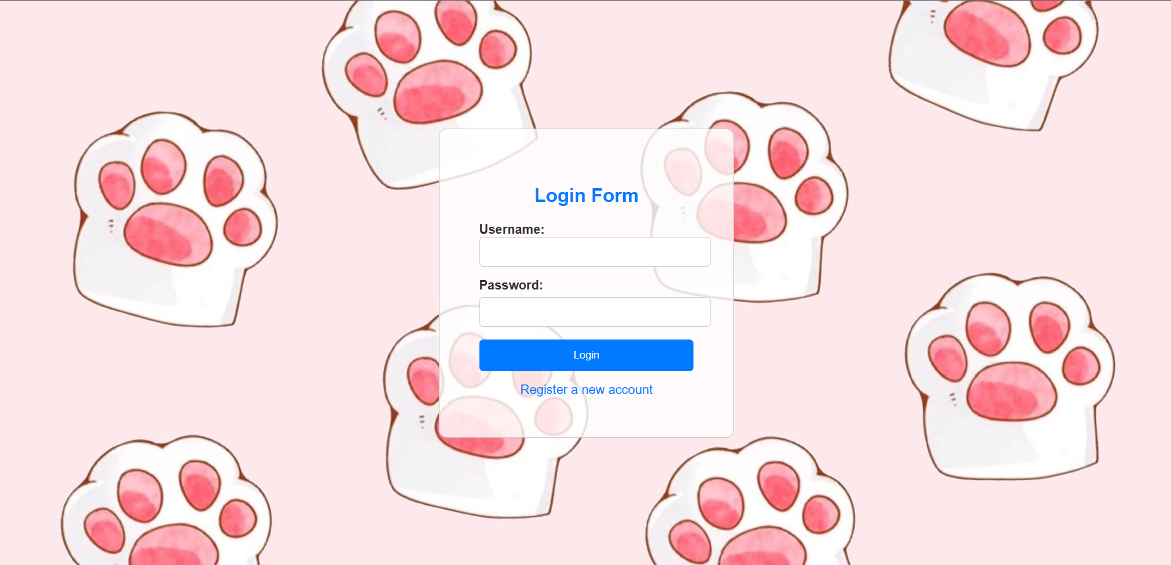

1. Registration:

* Function trigger: after clicking register button
* Function description: The system allows users to register for an account
* Screen layout:

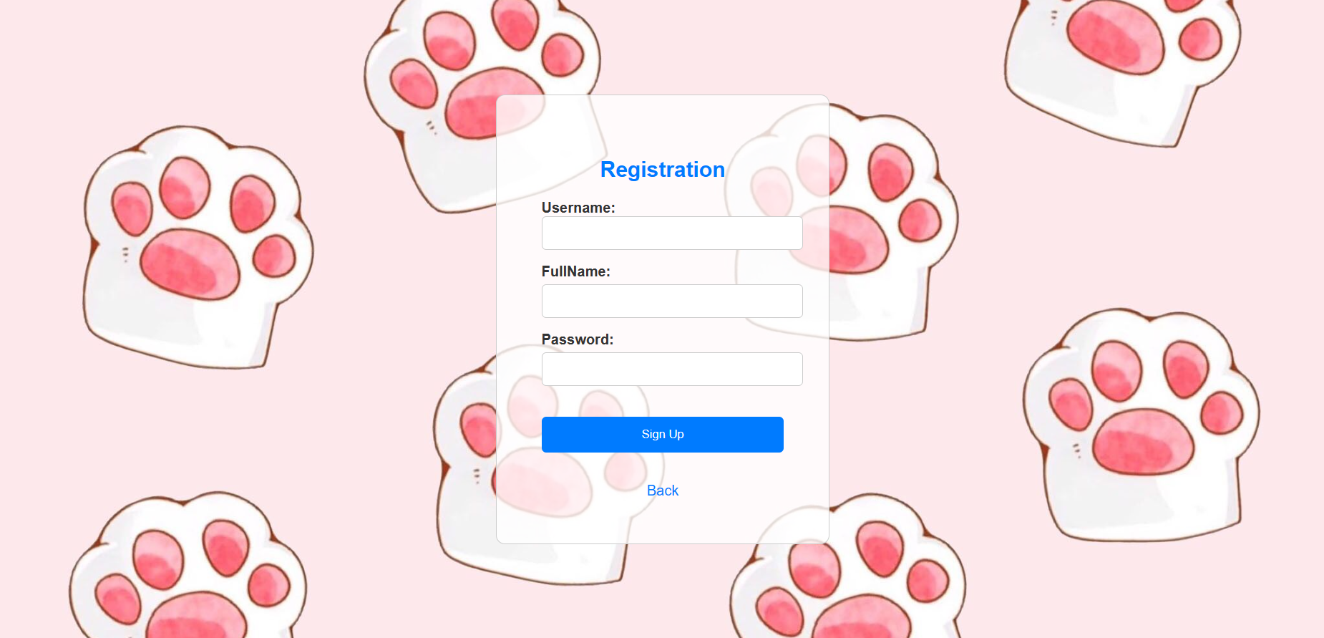

1. Admin Page:

* Manage product

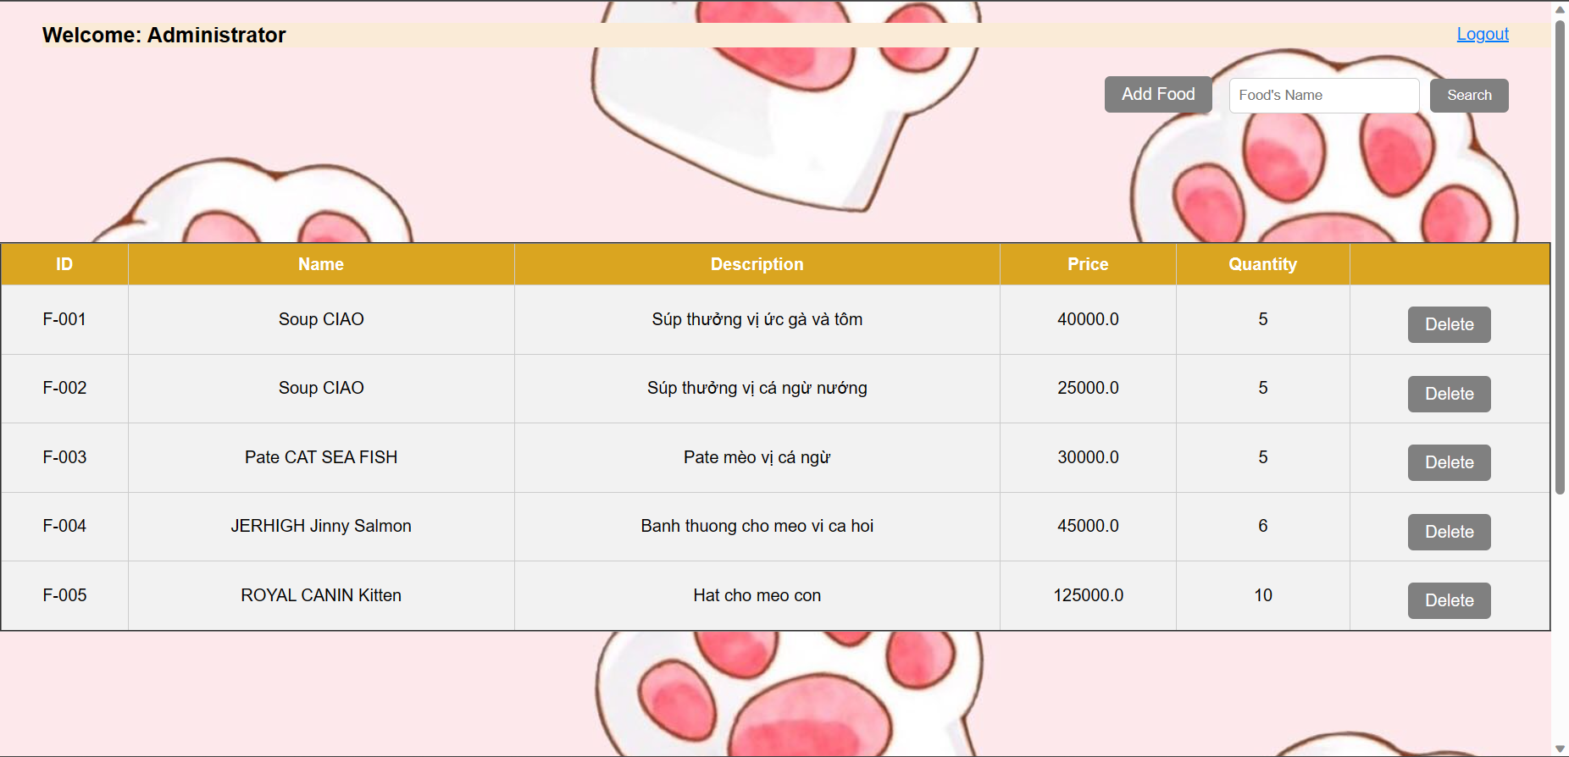

* Manage user accout:

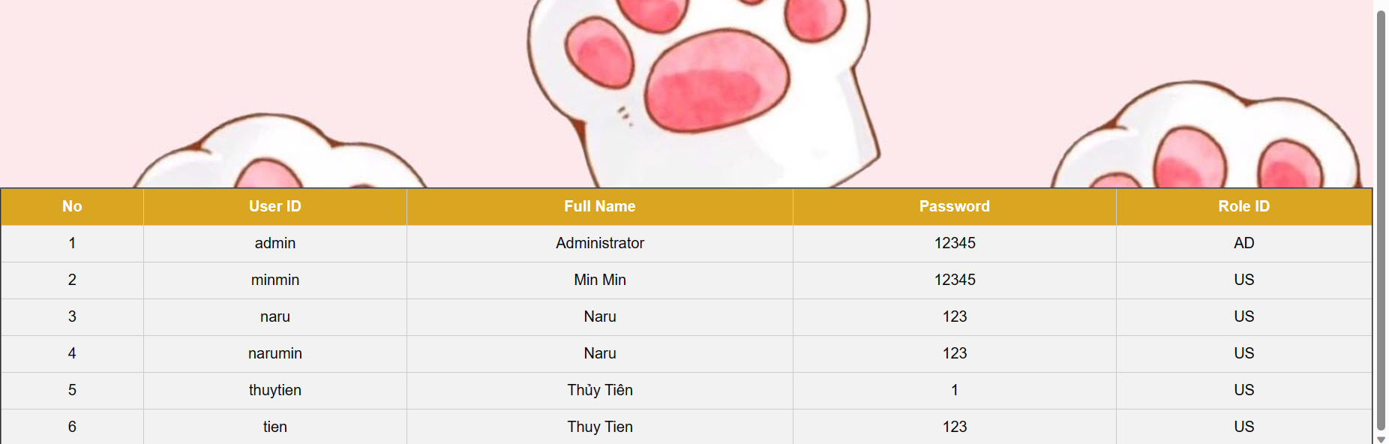

1. Shopping page:

* Function trigger: after clicking login.
* Function description: the system shows the shopping page for user.
* Screen Layout:

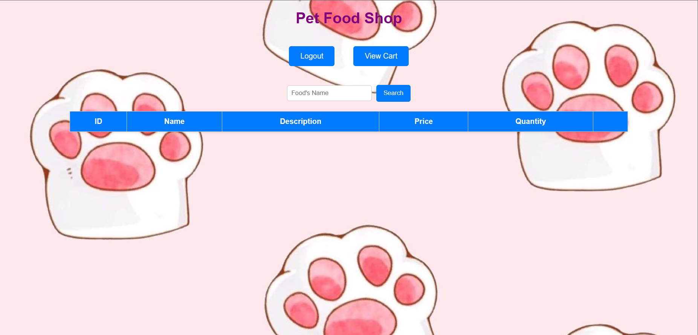

1. Show list of food:

* Function trigger: clicking Search button.
* Function trigger: at the shopping page will show the list of food.
* Screen Layout:

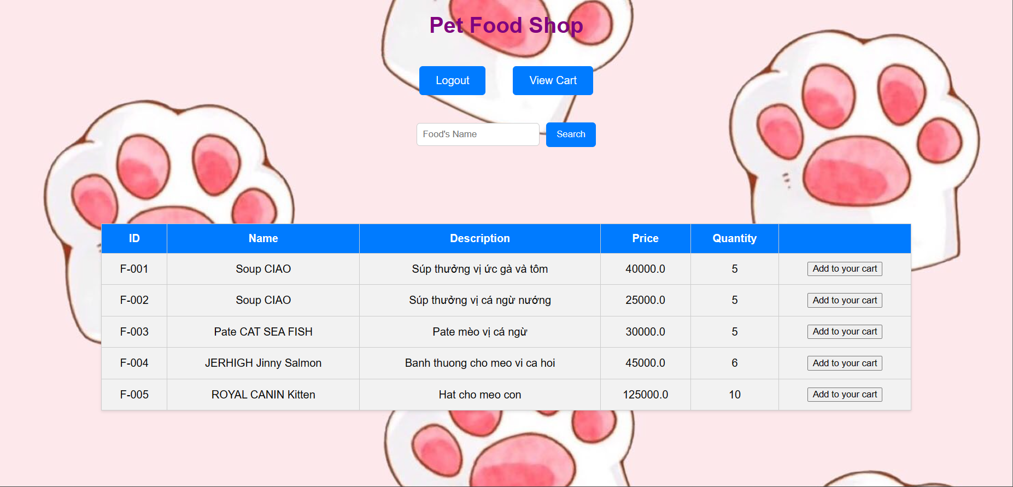

1. Search by Name:

* Function trigger: after choose name’s food clicking search button
* Function description: Display food according to user’s search request
* Screen Layout:

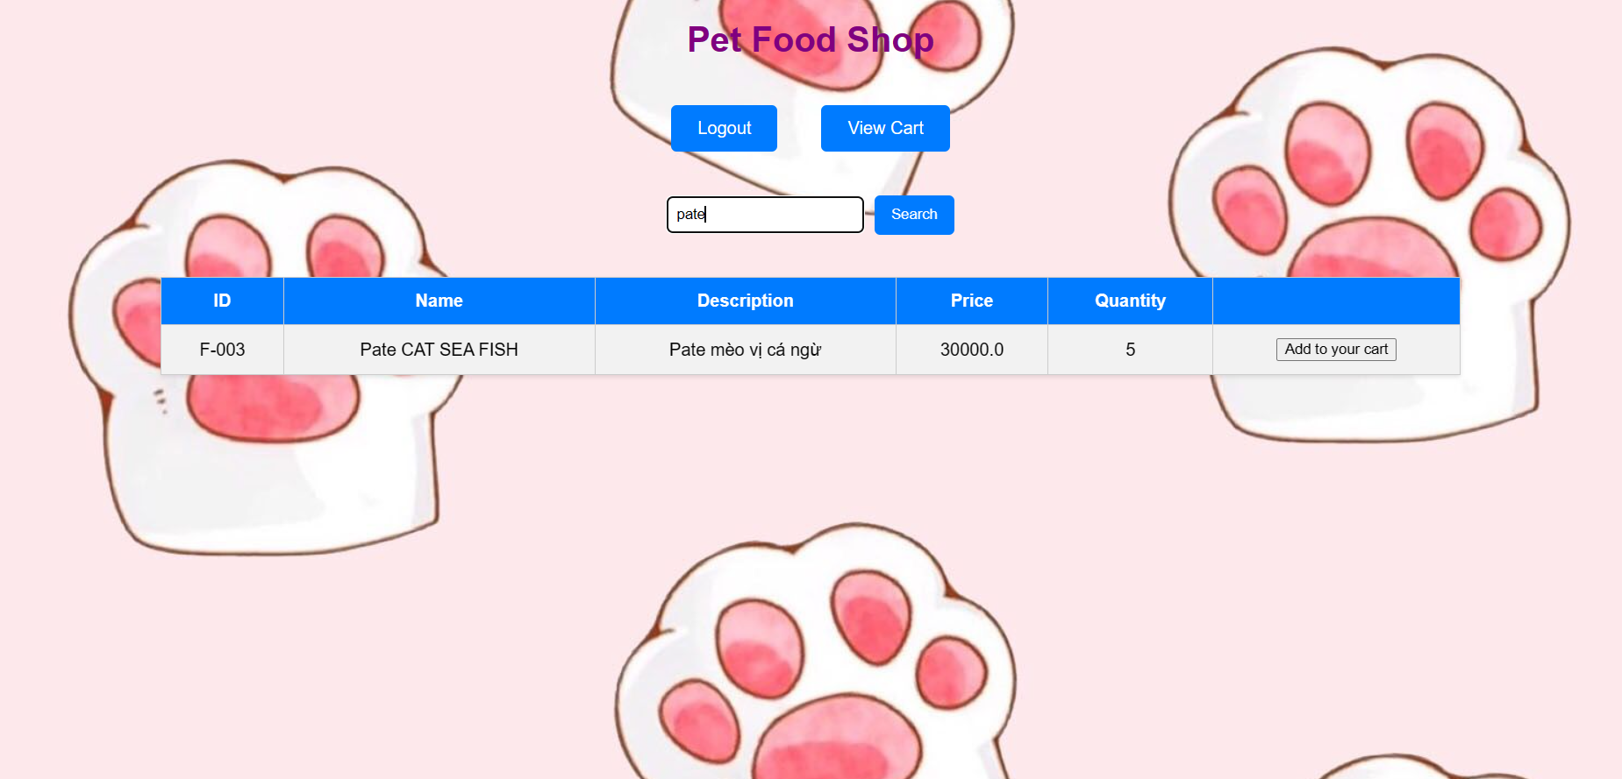

1. Confirm Order:

* Function trigger: after choose food clicking view cart button
* Function description: Display information and total price of food which user choose
* Screen Layout:

